Department of Computer Science and Engineering

# Project Plan Document

**TEAM DETAILS:**

|  |  |
| --- | --- |
| **NAME** | **SRN** |
| MOHAMMAD SAYEED AKRAM | PES2UG20CS201 |
| NAMAN PANDE | PES2UG20CS210 |
| RAGHAVENDRA M KATAGERI | PES2UG20CS261 |
| PARTH PRAVEEN SHETTY | PES2UG20CS240 |

**Things to be included as part of the project plan.**

1: Identify the lifecycle to be followed for the execution of your project and justify why you have chosen the model. (PES2UG20CS201,PES2UG20CS240)

Answer:

* Life cycle used in this project is Agile.
* We have clear visibility of our project.
* We are focusing on simplicity in both product and process.
* Lower Risk

2: Identify the tools which u want to use it throughout the lifecycle like planning tool, design tool, version control, development tool, bug tracking, testing tool. (PES2UG20CS201, PES2UG20CS261)

Answer: Tools used in our project are:

* Python programming Language.
* JIRA for designing
* MySQL Database.
* For tracking and testing, Gantt Chart is used.

## Department of Computer Science and Engineering

3: Determine all the deliverables and categorise them as reuse/build components and justify the same. (PES2UG20CS201, PES2UG20CS210)

Answer:

* Login Page
* Book Data
* Student Data
* Add Books
* Search Books
* Update Books
* Student Activity

4: Create a WBS for the entire functionalities in detail. (PES2UG20CS210)

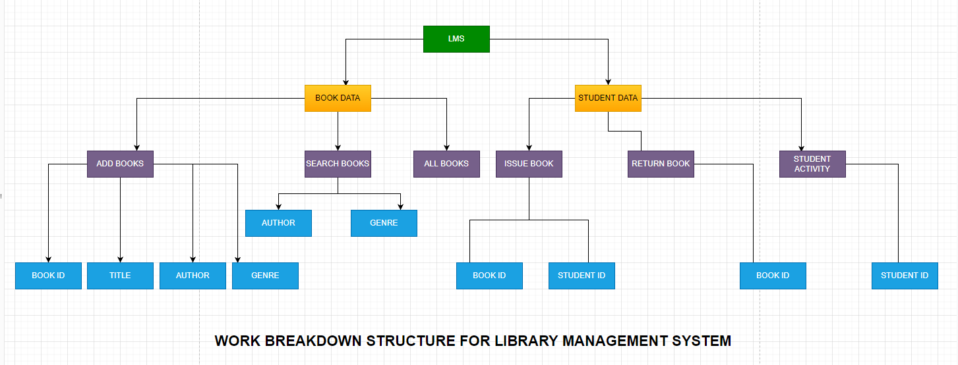

## Department of Computer Science and Engineering

5: Do a rough estimate of effort required to accomplish each task in terms of person months. (PES2UG20CS240)

Answer:

Basic COCOMO Model Values:

|  |  |  |  |  |
| --- | --- | --- | --- | --- |
| Software Projects | a | b | c | d |
| Organic | 2.4 | 1.05 | 2.5 | 0.38 |
| Semi Detached | 3.0 | 1.12 | 2.5 | 0.35 |
| Embedded | 3.6 | 1.20 | 2.5 | 0.32 |

Since we are beginners, we are going to use the **Organic Basic COCOMO model** to estimate the effort required to accomplish each task in terms of person-months: -

Effort= a(KLOC)^b person-months time= c(Effort)^d months

Person required = Effort/ time

Therefore, Assuming we are going to write 1,500 lines of code, i.e., 1.5 KLOC,

then:

**Effort(E) = 2.4 * (1.5) ^1.05 = 3.67 person-months**

**Time(T) = 2.5 * (3.67) ^0.38 = 4.097 Months**

6: Create the Gantt Chart for scheduling using any tool.

Answer: